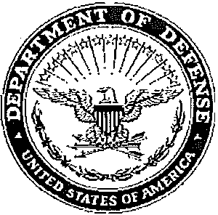

DEPARTMENT OF THE ARMY OFFICE OF THE CHIEF, ARMY DENTAL CORPS 3630 STANLEY ROAD, BUILDING 2840, SUITE 283 JBSA FORT SAM HOUSTON, TEXAS 78234-6100

ATMC-CCD XXXX2020

MEMORANDUM FOR RECORD

SUBJECT: Request Star Note for Military/Civilian Retirement or other occasion

NAME: XXXXX

RANK: GS-XX/XX (Series XXXX)

SPOUSE’S FULL NAME: XXXXXXX

MARRIED 10 YEARS OR MORE? Y/N

BRANCH OF SERVICE: XXXXX

YEARS OF SERVICE: XXXXXX – XXXXXX (XX years)

CURRENT POSITION: XXXXXXXXXXX

DATES SERVED IN CURRENT POSITION: XXXXXX – present

BACKGROUND INFORMATION: ORB/ERB/CRB and supportive narrative must be attached. Use this space for a brief narrative. Ms. XXXXXXX is cited for exceptionally meritorious performance of duty as a XXXXXXX at the United States Army Dental Activity, XXXXX from XXXX to XXXX.

JUSTIFICATION NARRATIVE: (ATTACHED, APPROVED BY CDR/DIR): XXXXX

PRESENTATION DATE: XXXXXX RETIREMENT DATE: XXXXX

DISPOSITION INSTRUCTIONS (ADDRESS WHERE NOTE IS TO BE MAILED):

COMMANDER
US Army Dental Activity
ATTN: Name
XXX Main St.
Fort Living Room, ST 12345-6789

POINT OF CONTACT: Name, email, phone.

NO SIGNATURE BLOCK

